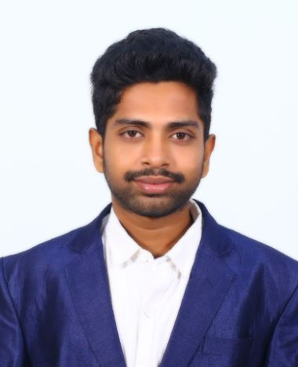

Srihari Maddineni received his B.Tech Honors in Information Technology from Bapatla Engineering College, Bapatla, Andhra Pradesh, India, in the year 2024. He is currently working as an intern at S4H Technologies.

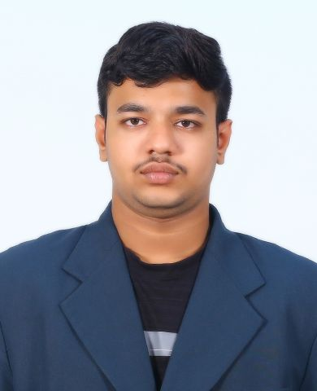

Kommineni Bhargava Rama Chowdary received his B.Tech Degree in Information Technology from Bapatla Engineering College, Bapatla, Andhra Pradesh, India, in the year 2024. He is currently working as an intern at S4H Technologies.